Psychological Containment: A Critical Leadership Success Factor
Marc Maltz and Steve Freeman Jul 27 · 13 min read

In a pandemic, physical hygiene becomes a #1 priority. But current conditions present extensive challenges to psychological hygiene. Organizations depend on psychological well-being to enable focus at work, team functioning and action in the interest of the whole. Yet few take psychological hygiene seriously and fewer still do all they should.
In the aftermath of 9/11, we developed a practice of psychological containment to enable organizational functioning under extreme conditions. Since then, we’ve worked with dozens of organizations both amidst crises and in periods of relative calm. In helping these firms, we’ve honed our understanding of psychological containment as a critical and largely overlooked leadership success factor — one that’s never been more needed.
The what and why of psychological containment
Containment, in simple terms, is the action of keeping something under control or within limits. That something could be political, medical, economic, military, etc., anything from the spread of a virus to the geopolitical influence of an adversarial nation.
Psychoanalyst Wilfred Bion¹ developed the term containment to describe the capacity to internally manage troubling thoughts, feelings and behaviors (TFBs). In psychotherapy, therapist and patient work together to contain the patient’s distress to get to a place of understanding, which, in turn, leads to the potential management of these feelings and the responses they evoke.
Output and process of organizations today is far more mental than material. As such, they act as cauldrons of all variety of TFBs from both within and beyond, including many that pose particular containment challenges:
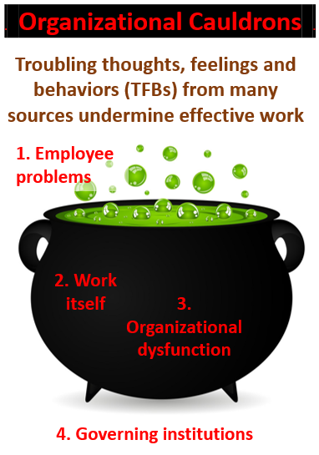
1. TFBs that individuals bring with them, e.g., their beliefs, political views, trauma, domestic problems, addictions, etc.
2. TFBs from the work itself, e.g., overly-repetitive work; dealing with sadness, pain and suffering; and extremely stressful work, including life-threatening situations. And not only from undesirable causes — office romance, for example, can be among the most important TFBs to contain.
3. TFBs from organizational dysfunction, e.g., unfair treatment, unmanageable workload, lack of role clarity or alignment, lack of communication and support from above.
4. TFBs that come from beyond the organization’s boundaries, its ecosystem, e.g., ineffective or oppressive governing institutions, overly powerful suppliers or customers, cut-throat or unfair competition, disasters (natural or man-made) and extreme uncertainty such as we’re experiencing with respect to Covid-19-related developments.
For an organization’s work to get done, TFBs must be identified, monitored and contained.

Why organizations can no longer ignore psychological containment
Most leaders and organizations have long been able to ignore psychological hygiene because TFBs created by their work and management processes (items #2 and #3 above) are absorbed by their people (#1) or a larger container (#4). Management gets by despite neglect or even abuse because unsung underlings — usually under-appreciated and often unrecognized — manage TFBs for them (sometimes at a significant personal cost).
Employees often bring TFBs home (e.g., high family violence rates from among law enforcement workers) or internalize them (e.g., high suicide rates by health care workers). Or the containing organization absorbs the costs. When large, powerful organizations or entire industries go bad such as in the financial crisis of 2008–2009, it wreaks havoc; communities suffer unemployment and abandonment and taxpayers pick up the bill.
In the current Covid-19 world, individuals and ecosystems are saturated, incapable of absorbing additional spillover. Organizations will not only have to better manage their own TFBs, but those that pour in from employees and beyond their own boundaries as well.
Successful leaders will not only have to contain TFBs that emerge in the workplace, but also ensure that those originating from beyond the organization do not derail the work.
Increasingly, leaders will have to recognize and monitor TFBs from all four sources, and use these data as critical input to how to guide the organization forward.
Unprecedented challenges in psychological hygiene
The past century’s declines in physical demands have been accompanied by increasing psychological demands.⁴ Our Covid-19 world produces unprecedented challenges including work-from-home — especially with children; the toll of too many sedentary hours spent on electronic devices; deterioration of trust in the absence of physical interaction and face-to face meetings⁵; deterioration of governmental and other institutional services; undermined routines, especially real world interactions with friends; and loss of many options for relaxation, enjoyment, rejuvenation and recovery.
For much of the workforce, it’s worse yet, including sickness, bereavement, absence of physical contact, separation from loved ones and general isolation.
The resulting upheaval in the economy adds to these stressors. Most people have concerns about the long- and even short-term viability of their job, organization and financial future.
Finally, add in recent social upheaval and any leader has to wonder ‘how can these not severely effect work?’
Learning from experience in the aftermath of 9/11
Current challenges are severe. Some organizations have already come apart; many others are barely holding together. As we continue into a long summer — on track to be the hottest on record — and (in the US) a contentious upcoming election, the prospects for productive work seem precarious. And, we have helped organizations through it.
We recently shared insights that derived from our research and work with Sandler O’Neill and Partners in the wake of 9/11⁵ on (1) effectively using crisis and (2) the astonishing power unleashed by combining a strong shared moral purpose with personal opportunity. But Sandler could not have gotten to that point had we not addressed the psychological needs of the survivors.
On September 11, 2001, Sandler’s office on the 104th floor of the World Trade Center was destroyed. Sixty-eight employees were killed, 40% of its workforce, including two of its three founders, one-third of its partners, almost their entire equities desk, its entire securities desk and all of its bond traders. Four visitors were also killed, all told, 72 co-workers, who were also spouses, parents, sons and daughters, and friends.

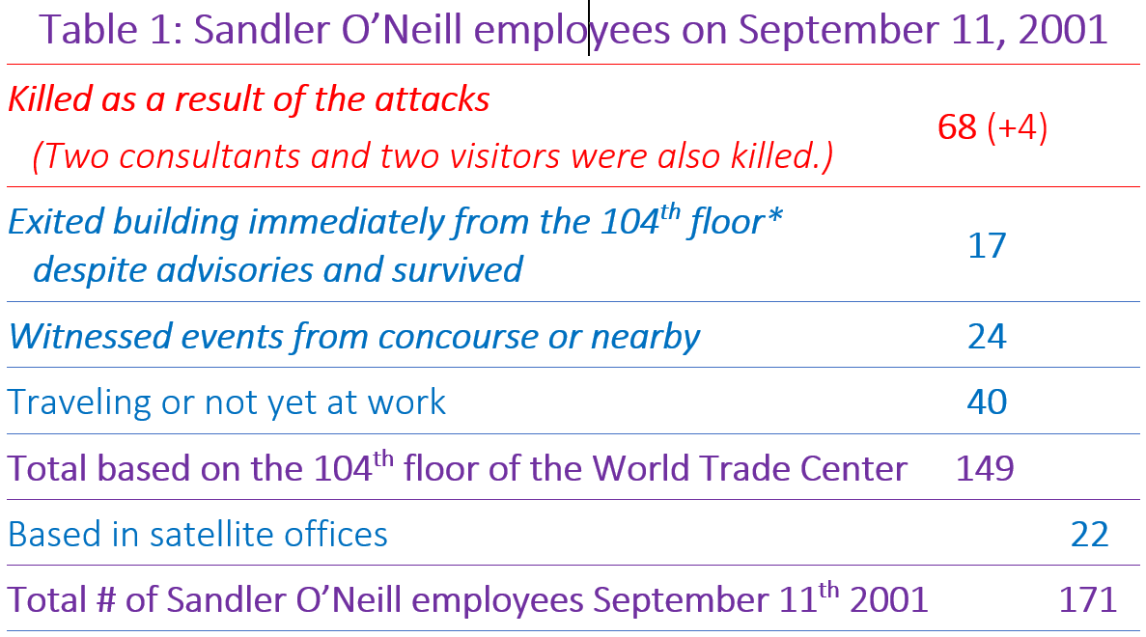
For greater depth, see the separate story on Sandler’s loss and recovery.

Deploying psychological containment
We were introduced to this tragedy the following day as survivors convened at a temporary space in mid-town Manhattan. That space allowed for taking stock, gathering and grieving. We began working immediately to care for survivors and the families of those lost as well as to consult about rebuilding.
Our consultation deployed psychological containment from the onset. We worked with surviving leadership to assure coverage for critical needs:
• Care for the families of the deceased;
• Care for employees;
• Communicating with customers/stakeholders;
• Communicating with governing authorities
• Media relations;
• Taking stock of and managing the business;
• And eventually, managing the numerous memorial services and the firm’s memorial service held at Carnegie Hall.
We also promptly established three teams of consultants and clinicians to:
1. Care for the families of the dead:
• Private counselling and group sessions for families;
• Retreats for the many children who lost a parent.
2. Care for employees:
• Private counselling for all employees;
• Workplace monitoring;
• Group counselling, initially divided into five groups by 9/11 experience:
- 17 who had been in their offices that morning, but left despite advisories,
- 24 who were on the concourse,
- 40 who were traveling or not yet at work that day,
- 22 who were in satellite offices, and
- the many volunteers who helped out in the initial weeks and new hires (it wasn’t easy for them either).
3.Work with surviving partners to rebuild the business.
Containing even extreme grief, distress, anxiety and trauma
In the aftermath of 9/11, grief, distress, anxiety and trauma were everywhere. Establishing immediate psychological safety was impossible. Would there be further attacks? Would this escalate into an extended crisis? Yet daily incremental progress was made, and containment was ultimately achieved through multiple efforts:
Leadership — what emerged as the most critical attributes were:
- Continuity — the sole remaining founder and managing partner, Jimmy Dunne, immediately formed a new team to lead the firm through the days (and years) ahead. Dunne and two colleagues established a core team in the spirit and image of the original managing partners, not to duplicate them but to replace what they brought to the firm.
- Confidence in the future — Despite the devastation, Dunne never wavered. He exuded the confidence for others to believe that the firm would survive, even thrive.
- Confidence in the present — Surviving partners used their presence to affirm that the business was under control and that others were doing their jobs thereby enabling employees to focus on their own work.
- Emotions — Appearing on MSNBC a few days after 9/11, Dunne broke down in tears. A tough Bear Stearns banker whose previous emotional displays were limited to angry dress-downs, Dunne’s emotional display gave permission to all involved to outwardly show their feelings. If Dunne could cry, so can I, dispelling the tough Wall Street persona, enabling a normal affect. This affect also helped people identify with Dunne and thus internalize his confidence and his emotional state as their own. When he expressed grief, he was openly expressing their collective and individual grief.
- Flexibility — Different situations call for different types of leadership. Dunne’s transformation was particularly remarkable. Previously he had been an enforcer, respected but rarely sought out; for that, employees would turn to the other two founders. But with his friends gone, Dunne and other leaders rose to the occasion and transformed themselves into what the firm needed on any given day.
Organization as a container — at Sandler, we also achieved containment through stakeholder support and other mechanisms:
- Monitored the mental and physical health of employees, their families and the families of those lost.
- Established a coordinated community of support:
- Partners and their spouses in frequent communications with assigned families;
- Colleagues “buddied-up” to monitor each other’s emotional and physical well-being;
- Support for clients and friends of the firm managed in the same spirit.
- Gradually merged support groups to bring together disparate experiences, find common themes and expand in time to the firm-as-a-whole.
- Aligned roles and responsibilities, established new standard operating systems and stress-tested the firm’s strategy and finances.
- Worked with the community, partners, managers and employees to lead the firm through a conscious reframing of the trauma from a tragedy to the establishment of a “renewed” firm.
Containing grief — the extent of trauma in this case was unfathomable. But along with professional therapy and support groups, the following helped create good enough containment to process individual and organizational grief:
- Managers and partners were taught to develop empathy and allow for the expression of emotions, building the firm’s capacity to care for its own.
- A room was set aside for anyone feeling overwrought, thereby reserving workspace for actual work. Those who could still not sustain work after many months and were provided generous packages as they left the firm.
- Even the memorial service that was held at Carnegie Hall added to the containment by offering a public display of grief, an honoring of those lost and a demarcation between what happened and what was to come. Caring for each other, an unspoken part of Sandler’s legacy prior to 9/11, was rebuilt in a way that attended to each person and the firm.

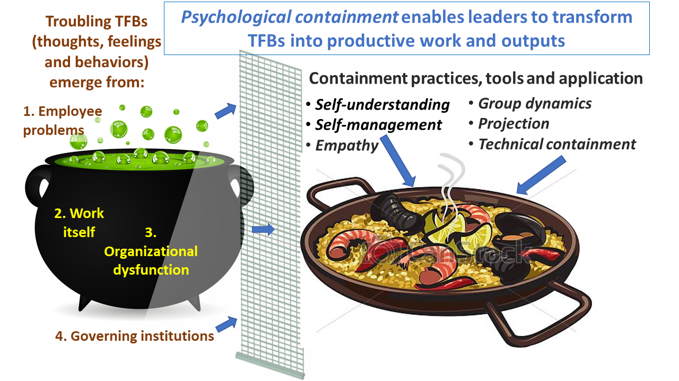
Psychological containment skills and practices enable leaders to transform potentially toxic TFBs into productive work and outputs
Psychological containment — a critical leadership success factor
We continued to work in a formal relationship with Sandler on these issues for five years, during which time the firm experienced an astonishing resurrection and sustained period of success, expanding into new markets, and steadily growing capabilities and profits.⁶
As we’ve worked with Sandler and dozens of other organizations in a wide variety of situations, we’ve honed our understanding of psychological containment as a leadership success factor.
Containment practice, tools and application
Containment is both psycho-social, helping to contain individual and collective stress and anxiety, and technical, establishing protective role and task boundaries.
Organizations are microcosms of society. The people who work inside and stakeholders who make up the organization’s ecosystem bring with them stressors that add to tensions experienced within. Leaders have to be sympathetic and empathetic to this myriad of stressors and work to contain them.
Managing these confluences can be a daunting task, and one that’s unique to every situation, for which we have collected an array of practices, tools and understanding. Among the most important that leaders generally need to master and employ are:
• Self-understanding. A leader needs to be able to first understand the range of their own TFBs, especially being in touch with their own affective range, including anxiety, anger and love.
• Self-management. The #1 cause of executive failure is lack of impulse control. Self-management is the ability to recognize and control emotional response. It’s being aware of triggers — physical, cognitive and/or emotional — and being able to manage their inward compromises in order to stay focused and outward displays to keep others focused.
• Projection. A “Silicon Valley” CEO⁷ on his way to a retreat rattles off directives to underlings who are preparing for a massive product launch. Shutting the car door, he adds, “Oh, the bear is sticky with honey.” Not knowing he was referring literally to a bear-shaped honey container, the puzzled underlings spiral out of control. They hold meetings to debate and interpret what he meant and completely redesign the product launch, even flying in a bear for the event. …
A leader’s passing comment, even a gesture, can be taken as mandate. Complicating matters are “projections” — a common means of defense subconsciously employed to cope with difficult emotions. Undesirable feelings may be projected onto others, including leaders, rather than recognized and dealt with. These can lead to assumptions at odds with intentions. To influence these projections, leaders must recognize emotional responses shaped by TFBs about role, company, etc….
• Group dynamics. Small teams have time and opportunity to explore others’ statements and TFBs and so to clarify intentions and perception. In large groups, people are often left to their own imaginations or collective anxiety. When unaddressed, these can feel like reality, leading them to act independently on fantasies, potentially in conflict with the leader or group.
• Technical containment is the act of providing structure, decision rules and clarity to work. Technical “boundaries” include defining roles and tasks, clear communications, decision-making transparency, and establishing authority and access to information. Done properly, this relieves anxiety and stress. Leaders must strike a balance; overuse of authority is as dysfunctional as underuse. Too much structure or too many rules can stifle innovation or make the group unsafe for those who don’t perfectly conform. Anxiety occurs at all organizational boundaries⁸, be it between individuals, roles, teams, departments and their broader stakeholders. Leaders must establish, align and monitor these boundaries so as to keep stress, anxiety and other potent emotions to manageable levels, and authoritatively respond if they threaten to spill over.
“No one cares how much you know, until they know how much you care.” ~Theodore Roosevelt
• Empathy. The world is full of experts who use knowledge primarily for their own advantage. T.R recognized that people are wary of advice — and wise to be wary — until they trust that those providing advice have their best interests at heart. So even a caring leader has to show that they care. That, in turn, requires an ability to empathize — to understand and relate to employees, colleagues, constituents and other stakeholders’ feelings, reasoning, perspective, position, and so on. This empathy is essential for (1) identifying underlying emotions and anxieties; (2) as data to inform actions to promote psychological hygiene; and (3) generating trust in those whose TFBs you hope to influence.
Psychological containment is challenging. It spans understanding and managing motivations, working with complicated individual and group dynamics, and listening below the surface to best align an organization.
What firms are facing now and how we’re trying to help
Recent months have been tough for everyone, including leaders: the initial Covid-19 fears, dread, lockdown and resulting economic uncertainty; the protests, riots and chaotic political and governing conditions; and now the continuing uncertainty about re-openings and the spread of the pandemic. It’s a minefield. Even the best of intentions can lead to blow-ups. For example, a brilliant but inexperienced leader of a tech startup arranged a “town hall” in the first days of the George Floyd demonstrations, to ensure employees would feel they were heard. In this town hall, he spontaneously called out minority individuals without warning and “offered” them the “opportunity” to share with the entire company their feelings on oppression and violence against “their community.”
Others have learned lessons from containment and are reacting cautiously, patiently and thoughtfully, with empathy, sharing relevant experience and from-the-heart sentiments. One cancelled work on election day in June and deployed forces to support local elections in minority neighborhoods. Another spoke from their experience of growing up as a racial and religious minority and made space for people to speak and listen across the many countries in which the company operates.
Leadership and psychological containment
Leading is more than developing the right vision, mission and strategy; more than marketing plans, financial statements and operations. Leading is about caring for the people who carry-out the strategy and operate the business. And showing them that you care.
Medium readers are likely familiar with concepts of psychological safety and emotional intelligence.⁸ Psychological safety critically helps provide an environment in which people trust their colleagues and can openly communicate. Emotional intelligence is necessary to deploy many of the containment tools noted above. But psychological containment requires considerably more from leadership, and more immediately relates to organizational output. It means containing not only one’s own stress, anxiety and other troubling TFBs from spilling out into the workspace, but those of everyone associated with the organization and its ecosystem.
It means containing as much of the stress, anxiety and negative emotions that arise beyond the organization from pouring in — and vice versa, limiting the toxicity that flows out into the environment. In short, containment is the critical leadership practice needed to provide a psychologically clean-enough workspace to allow people to focus at work, facilitate team functioning and do the right thing for the organization and beyond.
Psychological containment requires individual and organizational capabilities not normally expected of leaders, perhaps least of all for type A-personalities that generally rise to the top. It requires new tools, learning and ways of operating. It’s never easy, least of all now, and some will resist. Yet as we learned in the aftermath of 9/11 and in the two decades since, it can help organizations not only survive even the most devastating of disasters, but allow them to thrive. Even from amidst crisis and chaos, psychological containment can enable new heights of performance and success that you may never have imagined possible.

Authors

Marc Maltz — Partner — Hoola Hoop | LinkedIn
Marc Maltz has helped CEOs, Presidents, Boards and senior officers to develop and transform their organizations, manage…
www.linkedin.com

Steve Freeman - Crisalis research mentor, strategic advisor / Jefferson complex systems, strategic leadership professor of applied research
Advising and mentoring leaders in tech, health care, higher ed + on using research, leading through crisis and seizing opportunity …
www.linkedin.com

